Books | 1 month | 3 months | 6 months | 9 months | 1yrs | 2yrs | 3yrs | 4yrs | 5yrs | Total pages
Sri Isopanishad | 5 | 1.7 | 1 |  |  |  |  |  |  | 158
Krishna Book | 24 | 8 | 4 | 2.5 | 2 |  |  |  |  | 706
Nectar of Devotion | 13.5 | 4.5 | 2.2 | 1.5 | 1.13 |  |  |  |  | 407
Teachings of Lord Chaitanya | 11.5 | 3.8 | 2 | 1.2 | 1 |  |  |  |  | 347
Bhagavadgita As It Is | 29 | 10 | 5 | 3 | 2.5 | 1.2 |  |  |  | 868
Srimad Bhagavatam | 503 | 168 | 84 | 56 | 41 | 21 | 14 | 10.5 | 8 | 15119
Chaitanya Charitamrita | 221 | 74 | 37 | 25 | 18 | 9 | 6 |  |  | 6621
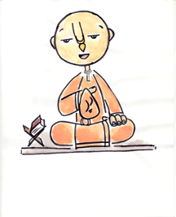
Be a Sage, Page by Page

Pages needed to complete in:

ISV 2008©

